Stage 3 - Living World
The Emu Cold Case
Brewongle Environmental Education Centre in conjunction with the NSW State Environmental Squad and the Australian True Crime Podcast journalistic team are about to re-open the very cold case of the missing Brewongle Emus. This case, from over four decades ago, will be looked at with the benefit of fresh eyes and cutting edge technology as new attempts are made to catch the killers.
The case is being re-investigated after the NSW Environmental Investigation Squad began assessing unsolved matters. The squad’s commander, Environmental Detective Charles Britten, says special detectives and investigative journalists will be working hand in hand to conduct formal reviews of the case. It has been more than 40 years since the Brewongle Emu was last seen and more than 20 years since any Emu was sighted in the Hawkesbury River region between Richmond and Wisemans Ferry as evidenced in the Atlas of Living Australia.
The review team will look at potential witnesses, new information and previous lines of enquiry. The unsolved environmental crimes squad was set up in 2016 and has so far solved more than 20 cases.

Inquiry Questions:
How do physical conditions effect the survival of living things such as emus?
How do structural and behavioural features of emus and other living things support survival?
Why is important for food and fibre to be produced sustainably?
Health and Safety Issues
As you are working out in the field you need to be aware that:
- Ground material is often covered in moss and can be very slippery.
- Vines and dense undergrowth can trip.
- Fallen trees can be rotten and weak.
- Some animals can deliver painful or venomous bites.
- On slopes, rocks can be easily dislodged.

Outcomes
ST3-10LW describes how structural features and other adaptions of living things help them survive in their environment
ST3-11LW describes some physical conditions of the environment and how these things affect the growth and survival of living things
ST23-2VA demonstrates a willingness to engage responsibly with local, national and global issues relevant to their lives and to shaping sustainable futures

Student Name: ___________________________________________________

Inquiry Aim:
The aim of this Scientific Inquiry is to investigate the Living World, with a focus on examining the structural features and adaptions of living things that help them survive. You will also be considering how the physical conditions to the environment might also affect their growth and suvival. In particular you will be investigating how an Emu’s requirements for living and the way it lives has led to its mysterious disappearce at Brewongle and its rare sightings in the wild in Western Sydney.

Pre-Excursion Tasks
Complete this section at school before your Brewongle Excursion
First, take the Emu Quiz @ Brewongleeec.com.au
Show us what you know.

Lesson 1:
Read EMU by Clare Saxby and Graham Bryne with your class.
Afterwards:
- Draw a scientific drawing of an Emu.
- Use a lead pencil – all diagrams in science should be drawn using pencil not pen.
- Show its physical characteristics, label the parts of his/her body as described in the book.
- Write a brief description of each part and how the emu uses it.

Use the area on the following page to undertake your scientific drawing of an emu.

Lesson 2:
Go to Page 4 of this work booklet and you will find information about scientific tests you can undertake to investigate whether or not the environment at Brewongle is suitable for Emus. In a group of 3 or 4 chose which 4 tests you will undertake. Provide an explanation of why you think it is important to investigate your chosen tests in relation to Emu needs and habitat requirements.

FEATURES:
1. __________________
____________________
____________________
____________________
____________________
____________________
____________________

2.__________________
____________________
____________________
____________________
____________________
____________________
____________________

3.__________________
____________________
____________________
____________________
____________________
____________________
____________________
SCIENTIFIC DIAGRAM OF AN EMU
Emu: Dromiceius novaehollandiae

Scientific Tests - Are the physical conditions at Brewongle suitable for supporting an emu? Is it possible that the physical conditions are unsuitable and have led to the disappearance of the Emu from Brewongle and surrounds? As special environmental investigators working for Environmental Detective Charles Britten, you need to choose 4 tests that will help you discover whether or not abiotic factors have played a part in the disappearance of the emu.

Look up the meaning of abiotic and write it down here:
Abiotic:____________________________________________________________________________
__________________________________________________________________________________

Choose 4 from these 8 tests. Circle the number of the tests that you have chosen and copy which tests you are undertaking into the results table on the next page.

 | TEST NAME | TEST DESCRIPTION
1 | Soil pH | Tests for acidity of soil. If soils are too acid or the opposite – alkaline/basic then there will not be the nutrients in the soil that the plants will need to grow.
2 | Soil Temperature | Soil temperature affects which plants will grow. If it is too hot or too cold pants will die or not be able to germinate (sprout from seeds).
3 | Soil Texture | Soil texture refers to the sand and clay content of soils. Sandy soils lose water very quickly after rain and clay soils will hold onto water. When there is lots of rain clay soils will get boggy. Each of these types of soils can influence what plants grow in them.
4 | Leaf Litter Depth | Leaf litter depth can help soils retain (keep water) available for plants. It also provides habitat for insects.
5 | Invertebrate Count | Invertebrates are insects. Insects in the soils show that there is water and nutrients available. Insects are good food for many animals.
6 | Slope | How steep the slope is influences how much water soaks in for trees to use, how much soil is washed down hill and whether or not an animal will be able to move comfortably in the environment.
7 | Light Intensity | How much light comes through the canopy (tree tops) can influence how many and what sort of plants grow.
8 | Air Temperature | Air temperature influences how plants and animals survive.

Why might plants be important for animals such as emus? Think of at least 3 reasons.
1. _____________________________________ 3. _____________________________________
2. _____________________________________ 4. _____________________________________
Pre-Excursion Lesson 2 & Excursion Activity 1
NAME OF CHOSEN TEST | WHY DID YOU CHOOSE THIS TEST? WHY IS IT IMPORTANT FOR EMU SURVIVAL? | TEST RESULT | Within Range YES/NO

TEST RANGES SUITABLE FOR EMUS
 | TEST NAME | RANGE
1 | Soil pH | 6 – 8 pH
2 | Soil Temperature | 5-20°C
3 | Soil Texture | Clayey Sand  Sandy Loam  Sandy Clay Loam
4 | Leaf Litter Depth | >2cm
5 | Invertebrate Count | >6 insects
6 | Slope | 0-15°
7 | Light Intensity | >500 lux
8 | Air Temperature | 5-40°C
TESTING CONDITIONS
Date: ________________________________
Time: ________________________________
Weather: _____________________________

Report Recommendation for Environmental Detective Charles Britten.
The abiotics indicate that the Brewongle environment is ______________________________________
_____________________________________________________________________________________
_____________________________________________________________________________________
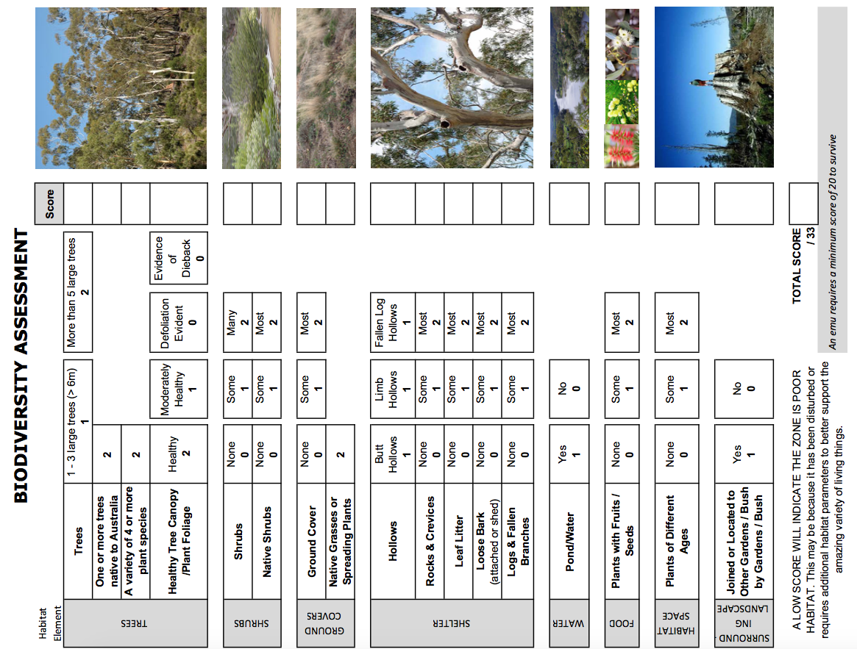

Report Recommendation for Environmental Detective Charles Britten.
Bio-diversity levels show that __________________________________________________________
__________________________________________________________________________________
Excursion Activity 2
Tracks, scats and eggs.
Identify an emu track, a predator track and one other native animal track and draw a scientific diagram of each.
Scientists have found that emu scats were very important for ________________________________
__________________________________________________________________________________

Report Recommendation for Environmental Detective Charles Britten.
Potential cause: Predators include ______________________________________________________
___________________________________________________________________________________
Excursion Activity 3

Draw and label a picture of Aboriginal Fire sticks

Land Clearing

Remaining cleared areas are usually ______________________________________________________

____________________________________________________________________________________

Revegetated areas are usually ___________________________________________________________

____________________________________________________________________________________

Report Recommendation for Environmental Detective Charles Britten.
Potential cause: Land clearing after European settlement caused _______________________________
____________________________________________________________________________________
Prior to European settlement Aboriginal people managed _____________________________________
____________________________________________________________________________________

Excursion Activity 4

Food survey
Emu Food | None | Score | Some | Score | Many | Score | Combined Total
Native fruits |  | 0 |  | 1 |  | 2
Seeds |  | 0 |  | 1 |  | 2
New shoots of plants |  | 0 |  | 1 |  | 2
Insects |  | 0 |  | 1 |  | 2
Very small animals |  | 0 |  | 1 |  | 2
Animal droppings |  | 0 |  | 1 |  | 2
Totals

Draw a scientific drawing of a plant that you think would be good “tucker” for both humans and emus.
Common name of plant _________________________________________________
Scientific name of plant _________________________________________________
Why did you choose this plant? ______________________________________________________
________________________________________________________________________________
Report Recommendation for Environmental Detective Charles Britten.
Food sources show that Brewongle is ____________________________________________________
___________________________________________________________________________________
Post-Excursion Task

Podcast: All About Emus and their strange disappearance
You and your class are about to undertake a mammoth endeavour and make a class podcast about what you have learnt about Emus with a few strange and creative segments to add a little fun on the side.
(Watch the video and answer the question)
What is a Podcast?
__________________________________________________________________________________
__________________________________________________________________________________

To make the podcast you will be working in small groups (2 to 3 people) to create a 30 second to 90 second segment which will then be compiled into the Class podcast.
One group will act as hosts and develop a tag line and intro and outro. The other groups can choose one segment idea each from the list below (no double ups). One group may be responsible for compiling the podcast or the whole class may be able to add each segment as it is finished.
Segment ideas:
- Hosts – Intro with Tagline and Outro (Wrap-up with tag line).
- Emu facts - What are emu characteristics and behaviours?
- How to do a habitat survey. What habitat does an Emu require?
- How do you measure soil samples and why soils are important for plants and animals such as emus?
- What food do Emu’s like to eat?
- A couple of emu jokes.
- A poem about emus (Remember to include the title and author even if you write it yourself).
- A small 1 minute play about emus talking to each other about important emu stuff.
- What is Aboriginal sustainability and how were emu populations kept sustainable?
- What is the best bush tucker? Plants and/or animals - Can you eat emu?
- What are Aboriginal Fire farming techniques? How is this good for animals and plants?
- Research the Great Emu War and present as a news report.
- How do you steal an emu egg from an emu?
- Where did the Brewongle emus go? – Human impacts
- What was great about the excursion to Brewongle?
Record segments using smartphone or school computer then edit using software free for school use such as Garage Band (Apple) or Audacity (Apple and PC).
When all segments, intro and outro are complete create a new file in Google Classroom to compile all recordings in a suitable format with Intro followed by segments with transitions between them and finish with the outro and possibly fading music.

Writing and recording considerations
- Chose the really interesting facts about each idea.
- Gross facts are always interesting.
- An interesting format is an interview. One student can be the expert (scientist or professor) and one the interviewer.
- Keep it short and to the point and do not add extra material just to make it longer. It just gets boring and who wants to be boring.
- Write out what you are going to say.
- Practice it out loud many times over, who knows if you do this you might be able to remember it word for word when you are 50.
- Consider music sound clips or sound effects to include in your segment.
- Consider music for transitions between segments and the intro and outro – use free online audio files. Source these before you begin recording your segment.
- Remember to speak slowly and clearly when you are recording.
- Record a few times and chose the best recording.
- Adjust the sound levels using the program controls if it is too soft or loud.
- Copy the best recording and add in sound clips and/or effects. Keep the original recording in case you make mistakes and have to try again.
- It is best to record in a quite space with no background noise. In other words, do not record in a busy classroom or playground.
- Collate individual segments, intro and outro into one file using Audacity or Garage Band and add in transition music.
- Export recording to class podcast folder in mp3 format.
Information for the Hosts.
INTRO
Don’t write this introduction until you have written the main part of your podcast. That means you need to know what your classmates have included in their segments before you can go ahead and create the teaser. So, work on your tag line until everyone else has told you what they are doing.
The teaser should get your audience excited about what you are going to talk about. Be sure to include all the usual stuff like the names of your host, the tag line, a quick overview of the podcast and whom the podcast is being produced for. For example - Brewongle Environmental Education Centre or Year 6C from Watt Evva Primary School.
Practice saying the Teaser out loud. Speak slowly so that everyone can understand you.
TAG LINE
Brainstorm and write down three clever, cool, or witty sayings that can be used for your podcast. Try making up tag lines that rhyme, use alliteration and/or humour.
Tag Line 1:
Tag Line 2:
Tag Line 3:
Practice saying your tag line to a lot of people and chose the one that gets the best reaction.
OUTRO
Short, sharp and sweet. Mention something learnt about emus in the podcast, the tagline and goodbye.

